**Alemseged Moges**

**Admission number DDA/003/006/2019**

**PGD002**

**Post Graduate Diploma in Water Hygiene and Sanitation Assignment 2**

**October 31st 2019**

1. Consider a disease known as diabetes mellitus, which is characterized by an increase in the blood sugar level. Infectious agents may contribute to the development of the disease in early childhood, but are not the main cause of the disease. Can it be classified as communicable? Explain your reasons

**Answer:**

The term disease refers to a disturbance in the normal functioning of the body and is used interchangeably with ‘illness’. Diseases may be classified as communicable or non-communicable. Communicable diseases are caused by infectious agents that can be transmitted to other people from an infected person, animal or a source in the environment.

Diabetes mellitus, commonly known as diabetes, is a metabolic disease that causes high blood sugar. The hormone insulin moves sugar from the blood into the body cells to be stored or used for energy. With diabetes, the body either doesn’t make enough insulin or can’t effectively use the insulin it does make (Watson, 2018).

Diabetes mellitus is not communicable; rather it is non-communicable because the main cause of the disease is not an infectious agent and it cannot be transmitted from a person with diabetes mellitus to another person with a causative agent.

1. How would you classify pulmonary tuberculosis using the epidemiologic method? What is the main importance of such classification?

**Answer:**

Communicable diseases can be classified in different ways into groups with similar characteristics. Accordingly, these diseases can be classified based on their clinical or epidemiologic features. Epidemiologic classifications are based on the mode of transmission of the infectious agent and include foodborne, waterborne, airborne and vector-borne diseases.

The importance of epidemiologic classification is that it enables us to select prevention and control measures which are common to other communicable diseases in the same class. This will enable somebody to interrupt the mode of transmission.

Pulmonary Tuberculosis (TB), an infectious disease caused by bacteria and spread through air, is preventable and treatable. Therefore, pulmonary tuberculosis would be classified using epidemiologic method by identifying its incidence, distribution, and design control of severity in a given community. When occurrence of the disease is diagnosed within a given population or community the infected individual, group and/or population should be isolated i.e. you may need to separate patients from others to prevent transmission to healthy people. For example, an adult case of active pulmonary tuberculosis should be kept in isolation in the first two weeks of the intensive phase of treatment. The isolation period lasts until the risk of transmission from the infected person has reduced or stopped. Therefore, treatment should be given, and control measures designed to prevent transmission after the disease has occurred.

Epidemiologic classification method in the control pulmonary tuberculosis has obtained a good result in a study conducted in Shandong province of China from 2005 to 2017 (Tao *et al* 2019). According to the study conducted, among 6283 (2.4% of all PTB) PTB cases aged <18years, 56.5% were male patients, 39.3% were smear-positive and 98.6% were new cases. The overall incidence of childhood PTB declined (7.62 to 3.74 per 100,000) during 2005–2017, with a non-significant change of annual percentage after 2010. While the incidence of smear-positive PTB (6.09 to 0.38 per 100,000 population) decreased significantly, but the incidence of smear-negative PTB (1.52 to 3.36 per 100,000 population) increased significantly during 2005–2017. The overall treatment success occurred among 94.2% childhood PTB. Ten children (0.2%) died. Therefore, this method should be practiced elsewhere to prevent, control transmission and spread of the disease.

1. Describe four or more bacterial vaccine-preventable diseases that have the same modes of transmission.

**Answer:**

**Table 3.1:** Bacterial vaccine-preventable diseases with the same modes of transmission

|  |  |  |  |  |  |  |
| --- | --- | --- | --- | --- | --- | --- |
| **S.no.** | **Diseases** |  | **Bacterial cause** | **Mode of transmission** | **Symptoms** | **Prevention and control method** |
|  | Tuberculosis |  | Mycobacterium tuberculosis | Respiratory by coughing or sneezing | Chronic cough, weight loss, fever, decreased appetite | BCG vaccine, Chemoprophylaxis, early diagnosis and treatment |
|  | Pertussis |  | Bordetella pertussis | Respiratory by coughing or sneezing | Runny nose, watery eyes, sneezing, fever, and continuous cough, followed by vomiting | Pertussis vaccine, combined with two or four other vaccines against diphtheria, tetanus, BCG, etc. |
|  | Meningitis (infection of the brain or spinal cord) |  | Neisseria meningitidis | Respiratory by coughing or sneezing | Fever, headache, neck stiffness, coma | Meningococcal vaccine and treatment by antibiotics |
|  | Pneumonia (infection of the lungs |  | Streptococcus pneumoniae | Respiratory by coughing or sneezing | Cough, fast breathing/difficult breathing | Treatment by antibiotics;  pneumococcal conjugate vaccine (PCV) |
|  | Pneumonia (infection of the lungs |  | Haemophilus influenzae | Respiratory by coughing or sneezing | Cough, fast breathing/difficult breathing | Treatment by antibiotics; Hib is part of the pentavalent vaccine |

1. What are the causes and methods for preventing bacterial meningitis?

Answer:

Meningitis is infection of the brain or spinal cord caused by bacteria called *Neisseria meningitidis*. Bacteria that cause meningitis can be spread through coughing, sneezing, kissing, or sharing eating utensils, a toothbrush or a cigarette. These steps can help prevent meningitis:

* Wash your hands.
* Careful hand-washing helps prevent the spread of germs.
* Meningococcal vaccine and treatment by antibiotics are also the main preventative method.

1. Explain two characteristics that illustrate how the Anopheles larvae are different from other mosquito larvae. Using illustration is advised

Two characteristics that distinguish the Anopheles larvae from other types are:

1. It has no breathing siphon.

2. It rests parallel or horizontal to the water surface.

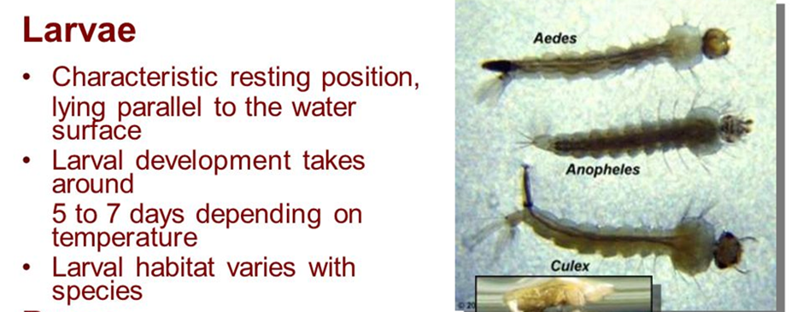

**Fig 5.1:** Characteristics of Anopheles larvae (Source: APA et al 2017)

**REFERENCES:**

APA: Sofizadeh, A., Moosa-Kazemi, S. H., & Dehghan, H. (2017). Larval Habitats Characteristics of Mosquitoes (Diptera: Culicidae) in North-East of Iran. Journal of arthropod-borne diseases, 11(2), 211–225.

Tao, N. N., Li, Y. F., Liu, Y. X., Liu, J. Y., Song, W. M., Liu, Y., … Li, H. C. (2019). Epidemiological characteristics of pulmonary tuberculosis among children in Shandong, China, 2005-2017. BMC infectious diseases, 19(1), 408. doi:10.1186/s12879-019-4060-x

Watson S. (2018). Everything You Need to Know About Diabetes: https://www.healthline.com/health/diabetes